SIMATS ENGINEERING
ASSESSMENT TOOL 1
COURSE CODE: | ITA 0606 | COURSE NAME: MACHINE LEARNING
COURSE OUTCOME COVERED
CO1: Learning Problems, Perspectives and Issues, Concept Learning, Version Spaces &
Candidate Elimination, Inductive Bias, Decision Tree Learning,
Representation & Heuristic Search (BL1, BL2)
Assessment Tool Weightage: 40%
QUESTIONS: 5 Total Marks: 25
Annexure A
APPLICATION BASED QUESTIONS
Code of Conduct:
I Nirmal Kumar T (192412003) certify that this submission is my original work and that I have
adhered to the guidelines specified for this assessment.
I understand that any violation of academic integrity rules will result in disciplinary action.
Signature of the student:
Nirmal Kumar T

1. Examine the performance of a machine-learning model using its training and
validation loss values over multiple epochs: (5 Marks)
(a) Epoch 1: Training Loss = 2.8, Validation Loss = 2.4
(b) Epoch 2: Training Loss = 2.5, Validation Loss = 2.2
(c) Epoch 3: Training Loss = 2.2, Validation Loss = 2.0
(d) Epoch 4: Training Loss = 2.0, Validation Loss = 2.1
(e) Epoch 5: Training Loss = 1.8, Validation Loss = 2.3
(f) Epoch 6: Training Loss = 1.6, Validation Loss = 2.6
(g) Epoch 7: Training Loss = 1.5, Validation Loss = 2.9
(h) Epoch 8: Training Loss = 1.3, Validation Loss = 3.2
i) Identify the epoch at which the model begins to overfit. ii) Suggest two effective techniques
to reduce overfitting in this model. iii) Discuss how overfitting affects the model’s
generalization ability on unseen data.
Answer:
i) Identify the epoch at which the model begins to overfit.
A model begins to overfit when the training loss continues to decrease while the validation loss
starts increasing.
Epoch Training Loss Validation Loss Observation

1 | 2.8 | 2.4 | Both decreasing

2 | 2.5 | 2.2 | Both decreasing

3 | 2.2 | 2.0 | Both decreasing

4 | 2.0 | 2.1 | Validation loss increases →Overfitting begins

5 | 1.8 | 2.3 | Overfitting continues

6 | 1.6 | 2.6 | Severe overfitting

7 | 1.5 | 2.9 | Severe overfitting

1.3 | 3.2 | Severe overfitting

8

Answer:
The model begins to overfit at Epoch 4.
Reason:
From Epoch 4 onward, the training loss decreases (2.2 →2.0 →1.8 →1.6...), but the validation
loss increases (2.0 →2.1 →2.3 →2.6...), indicating the model is memorizing the training data
instead of learning general patterns.
ii) Suggest two effective techniques to reduce overfitting.
1. Early Stopping
• Stop training when the validation loss starts increasing.
• In this case, training should stop around Epoch 3, where the validation loss is the lowest
(2.0).
2. Regularization
• Apply techniques such as L2 regularization (weight decay) or Dropout.
• These methods reduce model complexity and prevent the model from memorizing the
training data.

iii) Discuss how overfitting affects the model's generalization ability on unseen data.
Overfitting causes the model to learn the training data, including noise and unnecessary details,
instead of learning general patterns.
As a result:
• It achieves low training loss and high training accuracy.
• It performs poorly on validation and unseen test data.
• Prediction accuracy on new data decreases.
• The model becomes less reliable in real-world applications.
2. Examine the performance of a machine-learning model using training and validation
accuracy over multiple epochs: (5 Marks)
(a) Epoch 1: Training Accuracy = 60%, Validation Accuracy = 58%
(b) Epoch 2: Training Accuracy = 65%, Validation Accuracy = 63% (c) Epoch 3:
Training Accuracy = 70%, Validation Accuracy = 68%
(d) Epoch 4: Training Accuracy = 75%, Validation Accuracy = 72%
(e) Epoch 5: Training Accuracy = 80%, Validation Accuracy = 73%
(f) Epoch 6: Training Accuracy = 85%, Validation Accuracy = 72%
(g) Epoch 7: Training Accuracy = 88%, Validation Accuracy = 70% (h)Epoch 8: Training
Accuracy = 92%,Validation Accuracy = 68% i) Identify the epoch at which the model starts
overfitting.
ii) Explain why validation accuracy decreases despite training accuracy increasing. iii) Suggest
two methods to improve validation performance.
Answer:
i) Identify the epoch at which the model starts overfitting.
A model starts overfitting when the training accuracy keeps increasing while the validation
accuracy stops improving and begins to decrease.
Epoch Training  Accuracy | Validation  Accuracy | Observation

1 | 60% | 58% | Both improving

2 | 65% | 63% | Both improving

3 | 70% | 68% | Both improving

4 | 75% | 72% | Both improving

5 | 80% | 73% | Best validation accuracy

6 | 85% | 72% | Validation accuracy decreases →Overfitting  starts

7 | 88% | 70% | Overfitting continues

8

92%

68%

Severe overfitting
Answer:
The model starts overfitting at Epoch 6.
Reason:
After Epoch 5, the training accuracy continues to increase (80% →85% →88% →92%), while the
validation accuracy decreases (73% →72% →70% →68%).

ii) Explain why validation accuracy decreases despite training accuracy increasing.
Validation accuracy decreases because the model overfits the training data. It starts memorizing
the training examples, including noise and unnecessary details, instead of learning general patterns.
As a result:
• Training accuracy keeps increasing.
• Performance on unseen (validation) data decreases.
• The model loses its ability to generalize.
iii) Suggest two methods to improve validation performance.
1. Early Stopping
• Stop training when validation accuracy stops improving.
• In this case, the best model is at Epoch 5, where validation accuracy is highest (73%).
2. Regularization
• Use Dropout or L2 Regularization (Weight Decay) to reduce overfitting and improve
generalization.
3. In an industrial process, an AI robot is assigned to segregate the front and back tires
automatically. Let the number of tires are 250 (125 front and 125 back tires). (5 Marks)
a) Front identified as Front: 119
b) Front identifies as Back: 06
c) Back identified as Back: 120
d) Back identified as Front: 05
Compute: Accuracy, Precision, Sensitivity, Specificity and F1-Score.
Code:
# Tire Classification Performance Metrics
# Confusion Matrix Values
TP = 119 # Front identified as Front
FN = 6 # Front identified as Back
TN = 120 # Back identified as Back
FP = 5 # Back identified as Front
# Calculations
accuracy = (TP + TN) / (TP + TN + FP + FN)
precision = TP / (TP + FP)
sensitivity = TP / (TP + FN) # Recall
specificity = TN / (TN + FP)
f1_score = (2 * precision * sensitivity) / (precision + sensitivity)
# Display Results
print("Performance Metrics")
print("-------------------")

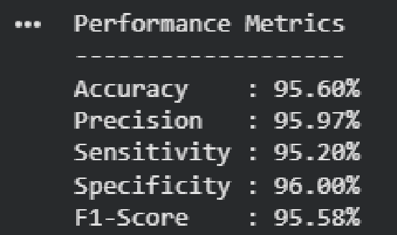

print(f"Accuracy : {accuracy * 100:.2f}%")
print(f"Precision : {precision * 100:.2f}%")
print(f"Sensitivity : {sensitivity * 100:.2f}%")
print(f"Specificity : {specificity * 100:.2f}%")
print(f"F1-Score : {f1_score * 100:.2f}%")
4. In a medical diagnosis system, an AI model detects whether a patient has a disease or not. Out
of 300 cases (150 diseased and 150 healthy): (5 Marks)
a) Diseased identified as Diseased: 138
b) Diseased identified as Healthy: 12
c) Healthy identified as Healthy: 135
d) Healthy identified as Diseased: 15
Compute: Accuracy, Precision, Sensitivity (Recall), Specificity, and F1-Score.
Answer:
# Medical Diagnosis System Performance
Metrics
# Confusion Matrix Values
TP = 138 # Diseased identified as Diseased
FN = 12 # Diseased identified as Healthy
TN = 135 # Healthy identified as Healthy
FP = 15 # Healthy identified as Diseased
# Calculations
accuracy = (TP + TN) / (TP + TN + FP + FN)
precision = TP / (TP + FP)
sensitivity = TP / (TP + FN) # Recall
specificity = TN / (TN + FP)
f1_score = (2 * precision * sensitivity) /
(precision + sensitivity)
# Display Results
print("Performance Metrics")

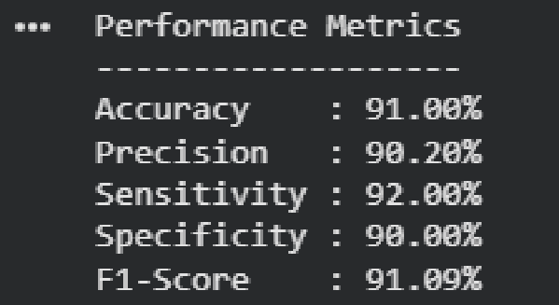

print("-------------------")
print(f"Accuracy : {accuracy * 100:.2f}%")
print(f"Precision : {precision * 100:.2f}%")
print(f"Sensitivity : {sensitivity * 100:.2f}%")
print(f"Specificity : {specificity * 100:.2f}%")
print(f"F1-Score : {f1_score * 100:.2f}%")

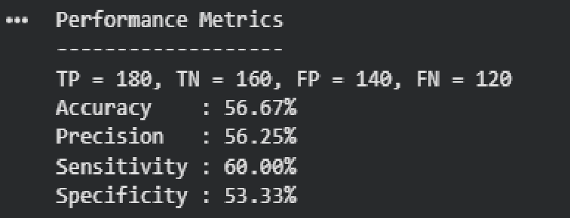

5. A medical image classification system using a deep learning framework combined with K-
Nearest Neighbor (KNN) yields TP = 180 and TN = 160. Each class contains 1200 samples,
and 25% of the dataset is used as test data.
Calculate: Accuracy Precision Sensitivity Specificity. (5 Marks)
Answer:
# Medical Image Classification Performance Metrics
# Given
TP = 180
TN = 160
# Dataset Information
samples_per_class = 1200
test_ratio = 0.25
# Test samples
positive_test = int(samples_per_class * test_ratio) # Diseased
negative_test = int(samples_per_class * test_ratio) # Healthy
# Calculate FP and FN
FN = positive_test - TP
FP = negative_test - TN
# Performance Metrics
accuracy = (TP + TN) / (TP + TN + FP + FN)
precision = TP / (TP + FP)
sensitivity = TP / (TP + FN)
specificity = TN / (TN + FP)
# Display Results
print("Performance Metrics")
print("-------------------")
print(f"TP = {TP}, TN = {TN}, FP = {FP}, FN = {FN}")
print(f"Accuracy : {accuracy * 100:.2f}%")
print(f"Precision : {precision * 100:.2f}%")
print(f"Sensitivity : {sensitivity * 100:.2f}%")
print(f"Specificity : {specificity * 100:.2f}%")

RUBRICS FOR CALCULATION
Criteria | Weightage | Level 4 –  Exemplary (5  Marks) | Level 3 –  Proficient (4 Marks) | Level 2 –  Developing (2–3 Marks) | Level 1 –  Beginning (0–1 Mark)
Conceptual  Understanding | 25 | Demonstrates clear and complete understanding of  the concept | Good  understanding  with minor gaps | Basic understanding  with some  misconceptions | Poor or incorrect  understanding
Accuracy of  Answer | 25 | Completely correct  answer with no  errors | Mostly correct  with minor errors | Partially correct  with noticeable  errors | Incorrect or  irrelevant answer
Application of Knowledge | 20 | Correctly applies concepts to solve  the  question/problem | Applies concepts  with minor  mistakes | Limited or partially  correct application | No or incorrect  application
Completeness of Response | 15 | Covers all required parts of the  question | Covers most  parts with minor  omissions | Covers only some  parts | Incomplete or  missing response
Clarity &  Presentation | 15 | Clear, concise, and well-organized  answer | Understandable with minor  issues | Somewhat unclear  or poorly structured | Difficult  to  understand

